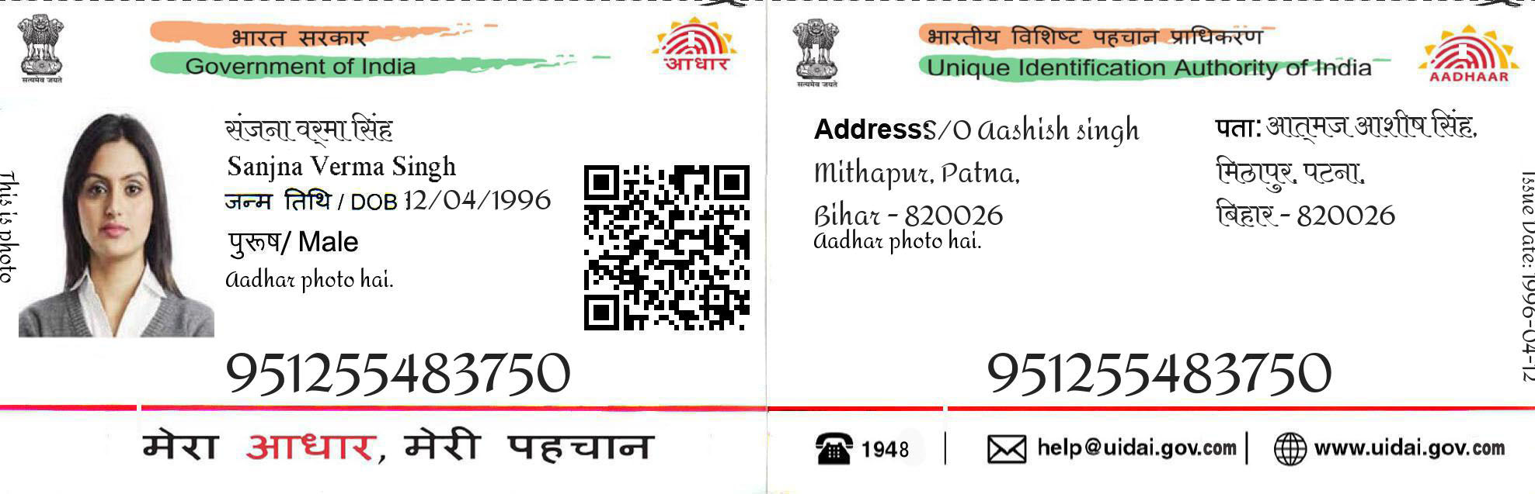

SALMAN KHAN

DOB 12/06/1996

MALE



**2548** **2648** **2748**



ADDRESS S/O SALMAN

PAKISTHAN

LAHORE - 637473

**2548** **2648** **2748**



www.uidai.gov.com

|

Help @uidai.gov.com

|

1537